Required Assignment 7.1:   
Determine the prioritising features for product design to satisfy the customer needs by using the Kano Model

**Anupam Shringi**

**Suggested time:** 120 minutes.

**Assignment Instructions**

Include the following in your submission:

1. The survey you have created,
2. The steps taken while performing Kano analysis.
3. Your observations and analysis gleaned from the activity.

***Note****: This is a required assignment and counts towards programme completion.*

**Product Statement for Kano Analysis.**

**Step 1: I want to launch a new snack brand for India market to compete with the existing snack brand using innovative taste and health features.**

**Step 2: I have framed the below features which are going into the design of the product:**

**Discrete analysis for the product survey shows where each feature is placed in a category:**

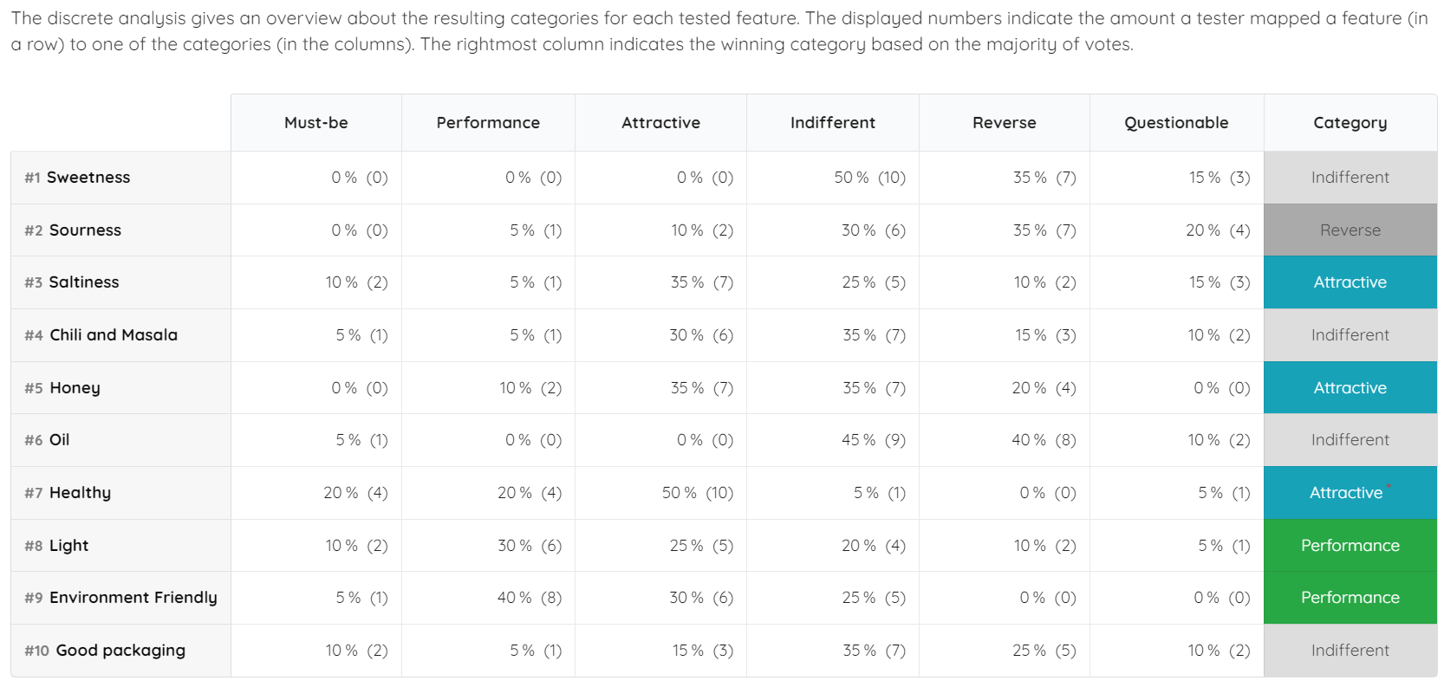

**Continuous analysis for the product survey**

In the two dimensional graph below the users have chosen features based on functional and dysfunctional parameters under attractive, performance and indifferent categories. By looking at the graph, we see that feature 9 – Environment friendliness falls under performance category and features 7 (Healthy) and Feature 8 (Light) fall under the attractive category. Rest all features fall under the indifferent category.

**Step 3: Evaluation table for the product survey**

In the above scenario, the users have chosen the **indifferent** category based on the functional & dysfunctional questions asked in the survey.

In the above scenario, the users have chosen the **performance** category based on the functional & dysfunctional questions asked in the survey.

In the above scenario, the users have chosen the **reverse** category based on the functional & dysfunctional questions asked in the survey.

In the above scenario, the users have chosen the **must-be** category based on the functional & dysfunctional questions asked in the survey.

In the above scenario, the users have chosen the **attractive** category based on the functional & dysfunctional questions asked in the survey.

**Step 4: Analysis Customer Satisfaction**

For the feature #5 Honey, the consumers are classified under the performance, attractive, indifferent, and reverse categories for the new snack product. Around 10% fall under the performance category while 35% fall under the attractive category.

Also, around 35% fall under the indifferent category while 20% fall under the reverse category.

Satisfaction Index = % Attractive + % Performance

(% Attractive + % Performance + % Indifferent + % Reverse)

= 45

100

**Satisfaction Index = 0.45 or 45%**

Dissatisfaction Index = % Indifferent + % Reverse

(% Attractive + % Performance + % Indifferent + % Reverse)

= 55

100

**Dissatisfaction Index = 0.55 or 55%**